Augmenting the Collective Intelligence of the Ecosystem of Systems Communities:
Introduction to the Design of the CI Enhancement Lab (CIEL)

In the opening speech at a systems conference in 2004 Russell Ackoff declared, the state of the world is a mess, and went on to saying:
“Reform will not do it; transformations are required, two kinds. First a transformation of the way nations and international institutions handle global affairs and second, a transformation in the way systems thinkers collectively conduct the systems movement. The second must come first if we hope to have any effect on the global mess.”

Introduction: an epic danger and opportunity
The combined impact of climate change, population explosion, social unrest in a growing number of countries, the water and energy crisis, organized crime and violent tribal/ethnic conflicts, and our zillion intertwining global crises is fully unpredictable. So is the combined impact of the global gift economy (brought to us by the Web), open source everything, the emergence of interconnecting movements for profound societal renewal, and the ever more capable tools for collaboration and cultivating collective intelligence at an increasing scale.
The simultaneous growth and acceleration of those two bundles of contemporary trends create an unprecedented, epic danger and opportunity for the systems movement. The danger is to dramatically reduce its relevance to societal evolution if it doesn’t find a way to engage with the mega-challenges of our time. Correspondingly, when an old world is dying and the new has yet to born, the epic opportunity lies in midwifing the new one. Will the systems movement step up to it?
Sure, there are individual systems thinkers and doers, who put their intellect and passion to be at service of large-scale evolutionary developments, which give us hope. However, this article’s focus is on what it may take to mobilize the collective intelligence of the ecosystem of systems communities, as whole.

Systems communities, movement, and ecosystem
Systems communities are one family of “epistemic communities” defined as a transnational network of experts and practitioners, who share a common discipline and “help decision-makers to define the problems they face, identify various policy solutions and assess the policy outcomes.” (Wikipedia) Those domains include, for instance: systems biology, systems dynamics, systems ecology, systems engineering, etc.
Some authors, like Ackoff, Checkland, Hammond, Laszlo, and others, talk about “systems movement.” For example, “Our patterns of being and becoming now need to match the patterns and processes of ecosystemic meta-stability found in nature and the cosmos at large… What are the patterns and processes currently alive in our world that intimate the possibility of co-creating a global eco-civilization? And how, and in what ways, must consciousness transform to propitiate such an evolutionary paradigm shift? These are some of the challenges posited by this paper in the hope that the Systems Movement in general, and the ISSS in particular, will take them up over the coming year and into the future.” (Laszlo, 2012)
Laszlo’s question begets another one: what qualities does what he calls “systems movement” must possess if it is to foster the transformation of consciousness required for humankind to pass its evolutionary test?
If the human species is to pass its evolutionary test, it needs to develop the patterns and processes of ecosystemic meta-stability that Laszlo referred to. For that to happen, the right enablers need to be in place, which include, in case of complex adaptive social systems, the self-organizing collective consciousness and intelligence of the ecosystem. In that context, only a smaller ecosystem that is part of the larger one can have any chance to influence the evolution of consciousness in the larger. That’s why we prefer to talk about an ecosystem of systems communities, or “systems ecosystem” for short, rather than “systems movement.”

The parts and response-ability of the systems ecosystem
The systems ecosystem include the various systems science organizations and their conferences, the systems-oriented virtual communities, distribution lists, journals, academic programs, learning laboratories, books, and the close 1.5 million webpages referencing “systems science.” Even this incomplete list reflects that this is a socio-technical-knowledge ecosystem, a complex whole with co-evolving parts.
What are the qualities that the systems ecosystem needs to possess if it is to become one of the enablers of evolutionary transformation in the larger ecosystem, the planetary patchwork of civilizations itself? Not assuming that the systems ecosystems already knows what those qualities are, the first of them is the capability of evolutionary learning, defined here as learning what it takes to develop the higher level of collective intelligence (CI) to boost the CI of the ecosystem of the human society.
Thus, the first response-ability of the systems ecosystem lies in the bootstrapping its own collective intelligence. “In it's simplest terms, bootstrapping means use what you build to boost your own effectiveness – it's the expectation that anyone working on an important aspect of boosting our Collective IQ capability will seriously push the envelope through their own experimental usage of their work products. (Engelbart, 2008) Hence, the systems ecosystem’s best starting point for advancing the transition to a sustainable and thriving world with ecosystemic meta-stability, is in prototyping evolutionary learning communities, capable to bootstrap their own CI.
For any systems community to collaboratively learn from the future, as the anticipated realization of the today’s evolutionary trends’ fuller potential, it must develop the capacity for collective self-refection and meaning-making, which are pre-requisites for collective intelligence and aspirations to emerge.
Ultimately, meeting the response-ability of the systems ecosystem to the societal need for an “evolutionary guidance system” (Banathy, 2000) starts with creating the enabling conditions for collective self-refection and meaning-making in its constitutive systems communities. This paper is focused on outlining the functions of and the infrastructure for one of those conditions, the emergence of collective intelligence in systems communities and the systems ecosystems, as whole.

Conscious evolution and evolutionary guidance systems

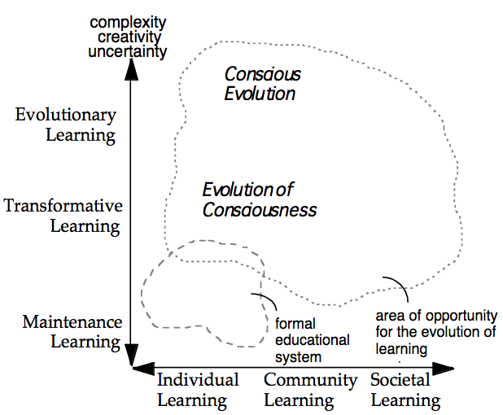
Figure 1. Evolutionary learning leading to conscious evolution (image source: Laszlo, 2003)
Transformative learning is a developmental process, in which individuals or collective entities expand their consciousness and transform their identity, by upshifting their worldview and correspondingly, revising their beliefs. Evolutionary learning goes beyond that: “Evolutionary learning empowers us to anticipate and face unexpected situations. It will help us to progress from unconscious adaptation to our environment to conscious innovation and coevolution with the environment and the development of the ability to direct and manage change.” (Banathy, 1996)
For communities, organizations, and other social holons, including the systems ecosystem, to make a contribution to the conscious evolution of larger societal systems, they first have to evolve their collective consciousness and intelligence through transformative learning. Collective consciousness is rooted in the “collective conscious” defined as “the set of shared beliefs, ideas and moral attitudes which operate as a unifying force within society” (Wikipedia). Collective consciousness is the shared identity that responds to the “who are we together” question of a group or social system. I will address the distinct issue of collective intelligence in the sections that follow.
For systems communities and the systems ecosystem, as whole, to fulfill their evolutionary potential, they also have to equip themselves with an innovation architecture capable to absorb the complexity of co-evolving with environment, particularly in times of such rapid modes of evolution as systemic bifurcation (Laszlo, 1991) or punctuated equilibrium (Eldredge & Gould,1972), also popularized as “jump time” (Houston, 2004).
For any collective entity to fulfill the promise and harness the full power of evolutionary learning, it must possess an evolutionary guidance system. “Evolutionary guidance systems are structured arrangements and operations, built into the human activity systems at all levels of society, that manifest evolutionary consciousness and enable the purposeful and guided evolution of human systems toward the realization of better futures for all.” (Banathy, 1987) The CommunityIntelligence Innovation Architecture represents such arrangement for the systems ecosystem, and will be used in the design phase.

Collective intelligence, its contexts, and the quadruple helix
Defined in an evolutionary context, collective intelligence (CI) is a shared or distributed intelligence that defines the capacity of groups, organizations, and social systems to evolve towards higher order complexity and harmony. It is an emergent property resulting from the operations of such evolutionary mechanisms as variation-feedback-selection and differentiation-integration-transformation of insights, knowledge and inspiration.
In an operational context, CI frequently refers to “a software supported collaborative design process that allows a group of individuals with a vested interest in understanding complex issues to reach a consensus about system interdependencies among sets of ideas such as problems, barriers, obstacles, goals and strategic objectives. CI enhances the collaborative power and action potential of groups who seek to work together toward the resolution of problems and the realization of possibilities.”
Looking at CI in its organizational dimension (between the evolutionary and operational context), it can be defined as “as the capacity of a collective to:
- sense its needs and that of its environment (stakeholders)
- generate choices that will satisfy those collective needs
- anticipate the consequences of those choices
- make choices that best serve the well-being of those affected by those choices
- learn from the consequences of those choices” (Veltrop, 2010)
A CI-boosting system, as part of the evolutionary guidance system, must be functional in all three scales or contexts: the evolutionary, the organizational, and the operational. It should be designed for seamlessly bridging them, thus allowing a full-spectrum user experience.
As any multi-disciplinary distinction, CI has a large number of definitions. For some, it is the "wisdom of crowds," for others it is that inter-subjective field which manifests when people interact from a beyond-ego space, just to refer to two of the popular branches of CI. Other contexts that contribute to the task of augmenting the CI of the ecosystem of systems communities include the cognitive, techno/computational and economic. For more, see Collective Intelligence and Collective Leadership (Pór, 2008).
CI is also described as relational intelligence, "integral, non-siloed systemic intelligence that conveys the capacity to engage a higher consciousness that synergizes the various forms of intelligence, exemplified by recent studies in consciousness and related fields, into one holistic engagement with experience.” (Laszlo, 2012) Emphasizing the relational aspect of CI is important as to enhance the use of the term reflected by the more technology-oriented question: "How can people and computers be connected so that -collectively- they act more intelligently than any individuals, groups, or computers have ever done before?"
Each of those contexts can be thought of as a particular lens, through which different meanings can be accessed and enhance each other. In one interpretation of intelligence, it can be measured by the number of perspectives that one can simultaneously embrace and act from. If so, the CI-boosting socio-technical system should facilitate the access to all of the perspective sketched out here, and doing that, to facilitate the co-evolution of individual and collective intelligence.
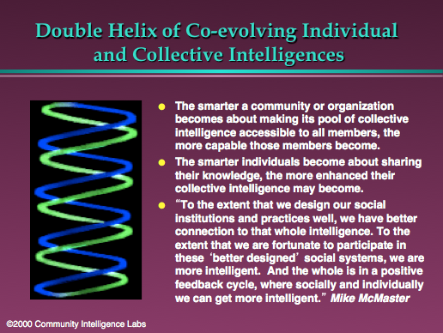
Figure 2. Double helix of co-evolving with individual and collective intelligences (Pór, 2000a)
In that double spiral, the altitude of CI is an intimately intertwining and co-evolving relationship with the intelligence of individuals. However, the first statement on the right of Figure 2 needs some refinement.
The World-Wide Web made available large quantities of the fruits of humankind’s general intellect (past and present), and doing so it contributed to millions of us becoming more capable in one domain or another. However, there’s also another factor playing strongly in defining the extent of that capability development. That’s our individual and organizational capacity for take up, for benefitting from the vast volume of information and knowledge available for free, which in turn, depends on the sophistication of our filtering, mapping, monitoring, and meaning making tools and practices. That leads to the next slide:

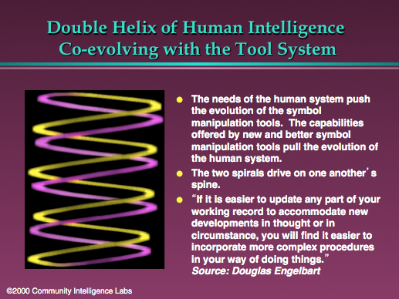
Figure 3. Double helix of human intelligence co-evolving with the tool system (Pór, 2000a)
Nobody has moved the edge of deep knowledge about that co-evolution more dramatically than the late Douglas Engelbart, the principal source of inspiration behind the suggested Collective Intelligence Enhancement Lab.
“Our innate abilities are augmented by a huge system of cultural practices, paradigms, procedures, customs, methodologies, and the like, which Doug termed the Human System, as well as a formidable physical system of artifacts, facilities, tools, media, machinery, and so on, which he termed the Tool System. Combined, these form our Augmentation System. For example, our ability to write a memo is possible because of Human System elements such as a learned understanding of the language, what a memo is for, and how to organize and unfold the information, as well as Tool System elements such as authoring and distribution tools, media, etc., all operating as an integrated and seamless Augmentation System. Capabilities change via changes in the Human and Tool Systems.
How we work together now emerged through centuries of gradual Human-Tool Co-evolution, changes in one side having a reverberating effect on the other. The Human System is generally much slower to adapt than the Tool System, and accounts for a much greater percentage of the challenge of pushing the capability envelope. Today we are witnessing the Tool System evolving at unprecedented speeds, while the Human System is evolving faster than ever but still lagging way behind what's possible in the Tool side.” (Engelbart Institute, 2008)
Engelbart’s map of the collective intelligence augmentation system is shown below.
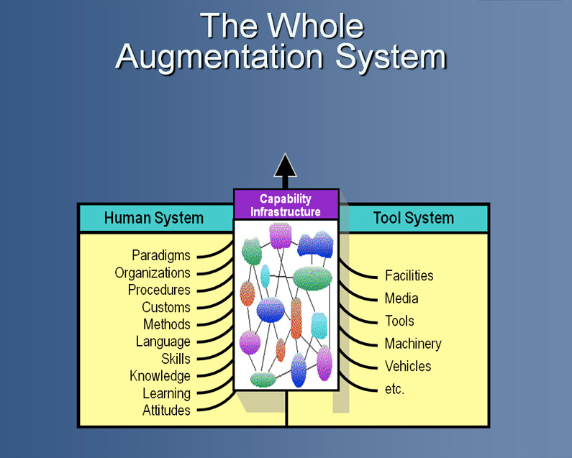
Figure 4. Our CI and capability infrastructure augmented by the co-evolution of the human system and tool system. (Engelbart Institute, 2008)
CI, as a socio-technical system thrives on the dynamic interaction between its two components depicted above. Dino Karabeg made a remarkable enhancement of that model, which is particularly relevant to the systems communities:
“Our value proposition is to streamline the development of ‘systems doing’ by combining suitably directed research in the systems sciences with suitably directed research and development in knowledge media (information technology). In this trans-disciplinary design research the systems sciences would provide the know-how for evolving or designing systems, while the knowledge media R&D would provide the tools and the materials.” (Karabeg, 2013)
The highest leverage of the suggested trans-disciplinary design research will, most likely, come from its impact on how the human/tool systems’ co-evolution may interact with the co-evolution of our individual and collective intelligence. See below.

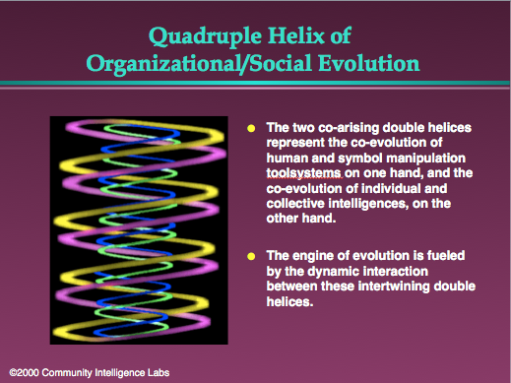
Figure 4. Quadruple helix of organizational/social evolution (Pór, 2000a)

The core idea and purpose of the suggested CI Enhancement Lab (CIEL)
A core idea is something that is at the source of why we came together to do something. It is a strong call from our core of being to be useful, to serve, to create, and to evolve. It is something that calls to us and it may alter the ways, in which system communities organize themselves for stewarding the collective intelligence of their membership.
The core idea of the CIEL initiative is to prototype an “emergent platform” that integrates
social, electronic, cognitive, and inner technologies and processes for augmenting
the collective intelligence of evolutionary learning communities,
and the systems ecosystem, as whole.

The specific purpose that CIEL and the process of developing it is designed to serve is three-fold:
- To create a testable alpha version of some basic elements of the CIEL concept, a scaffolding for the beta prototype, which we make available to the participants of the 57th conference of the International Society for Systems Sciences, and interested parties.
- To discover the next stage in the evolution of co-intelligent networks for curating the conditions for a thrivable planet (the central theme of ISSS57), by articulating an innovation-focused framework for a web-enabled, evolutionary guidance systems of epistemic communities.
- To lay foundations for an inter-disciplinary community of CI practice, comprised of researchers, students, designers, social innovation leaders, artists, etc., which could also serve as a “vehicle for enabling dialogue and collaboration among diverse and geographically dispersed individuals and institutions with a shared identity around innovating learning systems for sustainability” (IFSR Conversation 2010).

The concept of CIEL as a knowledge ecosystem
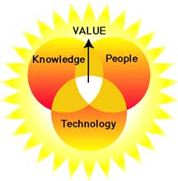

CIEL could also be thought of as a knowledge ecosystem comprised of three layers. It is a complex, self-organizing system of people interacting with each other and their knowledge and technical environments for growing collective intelligence and capabilities.
Knowledge ecosystems are comprised of an integrated triple network of:

a PEOPLE network of conversations that is producing
a KNOWLEDGE network of ideas, information, and inspiration,
supported by a TECHNOLOGY network of
wikis, forums, videos, blogs, and other infrastructure elements,
which generate social and scientific VALUE to their members and stakeholders.
Another way of envisioning CIEL is to think of it as a network of conversations that are richly hyperlinked with and feeding the user communities’ interactive repositories of knowing who, what, how, why, when, and the patterns connecting the conversations and the repositories.
In large organizations, a knowledge ecosystem is supported by teams of learning facilitators, information architects, web developers, and cybrarians, who support the tools and practices for the creation, organization, sharing, and use of knowledge. In the context of building an evolutionary learning system for self-organizing epistemic communities, we need to and can reach a capacity to absorb comparable levels of complexity, by bootstrapping our efforts.
That bootstrapping idea related to that context is outlined is in the diagram below, the original version of which appeared first in the paper on "Nurturing Systemic Wisdom through Knowledge Ecology" (Pór, 2000b).
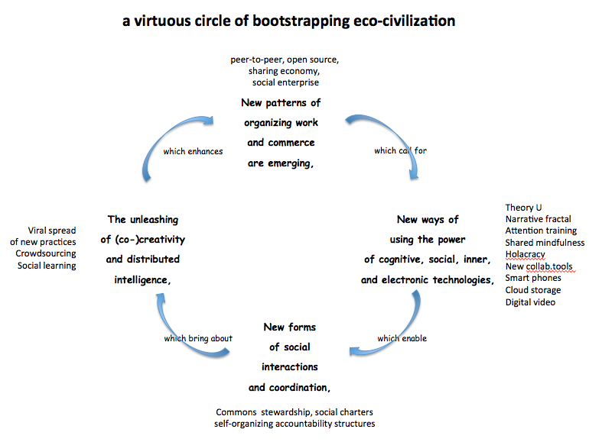
Figure 5. The cyclical positive feedback loops of bootstrapping and eco-civilization
Normally, a “positive feedback is a process in which the effects of a small disturbance on a system include an increase in the magnitude of the perturbation, That is, A produces more of B which in turn produces more of A.” (Wikipedia) In the cyclical feedback loop pictured above any improvement in A can produce more improvement in B, which in turn, similarly influences C, which influences D that in turn, influences A.
CIEL will be able to add some value to all four nodes in this virtuous circle, but we anticipate its largest impact on “New ways of using the power of cognitive, social, inner, and electronic technologies,” as well as “The unleashing of (co)-creativity distributed intelligence.”

Biomimicry-inspired design of the CIEL knowledge ecosystem
Recent developments in biomimicry studies inspire to learn from nature’s ecosystem as we design CIEL’s.

"Biomimicry follows Life’s Principles. Life’s Principles instruct us to: build from the bottom up, self-assemble, optimize rather than maximize, use free energy, cross-pollinate, embrace diversity, adapt and evolve, use life-friendly materials and processes, engage in symbiotic relationships, and enhance the bio-sphere. By following the principles life uses, you can create products and processes that are well adapted to life on earth." (Biomimicry Guild, 2008)

Until recently, biomimicry has been used primarily in industrial design and the development of new materials. As biomimicry expands from product and process design as application areas, to affect the design of social, knowledge, and technological ecosystems, the question becomes: What can we learn from nature's ecosystems, which would provide useful principles, metaphors and models to the design of CIEL?

“Biomimicry is the conscious emulation of life’s genius. The word ‘conscious’ refers to intent— it is not enough to design something without nature’s help and then in retrospect say, ‘This reminds me of something in the natural world.’… Biomimicry implies conscious forethought, an active seeking of nature’s advice before something is designed.” (Benyus, 2012)
- Our search for integrating biomimicry methods in the design framework of CIEL gave rise to the following research questions:
- What biomimetic information could guide systems communities to move toward greater effectiveness and efficiency in cultivating a shared mind?
- What essential, new information can we unearth if patterns of differentiation and integration (of thoughts, mental models and whole disciplines) common with the corresponding evolutionary mechanism in nature?
- What are the implications of the “neurons that fire together, wire together” process of memory formation for the design of system features and functions that support communal memory formation in knowledge gardens?
- What are the implications of the natural ecosystems' "edge effect" for discovering and articulating the principles, strategies, and functional requirements for the design of CIEL, capable to host a collection of knowledge ecosystems stewarded by a constellation of communities?
- What progress did system biology make in explaining biological ecosystems, which is exploitable for applications in designing CIEL?
A call for design collaboration
CIEL cannot be designed by one person. Its design calls for interdisciplinary collaboration, and even more so, for self-organization of an evolutionary learning community.
“"The evolution of evolutionary learning community is a purposeful process that starts with the creation of a Healthy and Authentic Community — which is the appropriate context for collaborative learning and design. When the community is ready to make the commitment to become a Learning Community, the members engage in a process of learning-how-to-learn that includes the development of evolutionary consciousness and evolutionary literacy. By subsequently developing evolutionary competence, the learning community can design itself into a Designing Community capable of continuous autopoietic re-creation as a community." (Laszlo, 2002)
We would use Banathy’s Social System Design, the starting point of which is generative dialogues, the source of authentic communities, which will precede our more technically focused conversations. If you feel called to explore what that may mean, don’t hesitate to get in touch with me at george.por@gmail.com or join the online conversation here:
http://cielcolab.com/groups/isss57/augmenting-CI-systems/forum/topic/introduction-to-the-design-of-the-ci-enhancement-lab-ciel/.

References

Laszlo, A. (2012) Increasing the Range and Reach of the Systems Sciences: a Call to Reinvigorate the Systems Movement, Incoming ISSS Presidential Address
Engelbart Institute (2008) About an Accelerative Bootstrapping Strategy, retrieved on July 13, 2013 http://www.dougengelbart.org/about/bootstrapping-strategy.html
Banathy, B. H. (2000) Guided Evolution of Society: A Systems View, Klouwer Academic / Plenum Publishers
Laszlo, A. and Laszlo, K. C. (2003) Evolutionary Learning Communities on the Web: Facilitating evolutionary learning through virtual learning environments
Banathy, B. H. (1996). Designing social systems in a changing world. New York: Plenum.
Laszlo, E. (1991) The Age of Bifurcation: Understanding the Changing World (World Futures General Evolution Studies)
Eldredge, N. and Gould, S. J. (1972). "Punctuated equilibria: an alternative to phyletic gradualism", in "Models in paleobiology", edited by Schopf, TJM Freeman, Cooper & Co, San Francisco. http://www.blackwellpublishing.com/ridley/classictexts/eldredge.asp
Houston, J. (2004) Jump Time: Shaping Your Future in a World of Radical Change. Sentient Publications
Banathy, H. B. (1987) The Characteristics and Acquisition of Evolutionary Competence, World Futures: The Journal of Global Education. Volume 23, Issue 1-2,
Veltrop, B. (2010) The Infinite Games Distinctionary, retrieved on July 14, 2013: http://www.theinfinitegames.org/e08/items/collective_intelligence.php
Pór, G. (2008) Collective Intelligence and Collective Leadership: Twin Paths to Beyond Chaos. PrimaVera Working Paper Series, University of Amsterdam http://academia.edu/982516/Collective_Intelligence_and_Collective_Leadership_twin_paths_beyond_chaos
Malone, T. (2006) The mission of the MIT’s Center for Collective Intelligence, retrieved on July 13, 2013: http://cci.mit.edu/
Pór, G. (2000a) The Value of Emergent Value Creation Models in the Knowledge Economy Towards a Framework for Analysis and Action. Position paper presented to "Consultation Meeting on the Future of Organisations and Knowledge Management" of the European Commission
ibid.
Engelbart Institute (2008) Accelerating the Co-Evolution, retrieved on July 14, 2013: http://www.dougengelbart.org/about/co-evolution.html
ibid.
Karabeg (2013) Bootstrapping Social-Systemic Evolution, paper presented to the 57th conference of ISSS
Pór, G. (2000a) The Value of Emergent Value Creation Models in the Knowledge Economy Towards a Framework for Analysis and Action. Position paper presented to "Consultation Meeting on the Future of Organisations and Knowledge Management" of the European Commission
IFSR Conversation (2010) retrieved on July 14, 2013: http://www.ifsr.org/index.php/ifsr-conversation-2010-pernegg/
Pór, G. (2000b) Nurturing Systemic Wisdom through Knowledge Ecology, The Systems Thinker, October 2000.
Biomimicry Guild (2008) retrieved on July 14, 2013: http://biomimicry.net/about/biomimicry/
Benyus, J. (2012) A Biomimicry Primer, retrieved on July 14, 2013: http://www.eomega.org/learning-paths/sustainable-living-nature-amp-environment/a-biomimicry-primer
Laszlo A. and Laszlo K. C. (2002) The Evolution of Evolutionary Systems Design. World Futures: The Journal of Global Education

